Computer Organization Lab 4

0616014 楊政道 0616225 張承遠

1. Basic Problem
2. DCACHE Miss Rate Graph

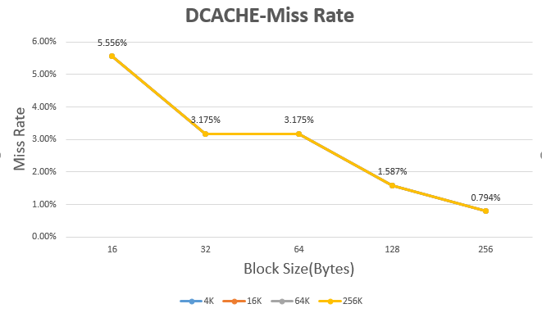

Analysis:

1. ICACHE Miss Rate Graph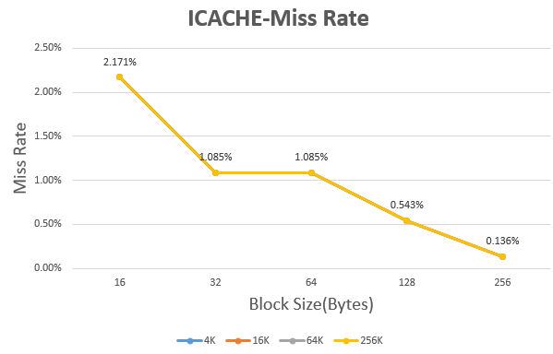

Analysis:

1. Advanced Problem:
2. LU

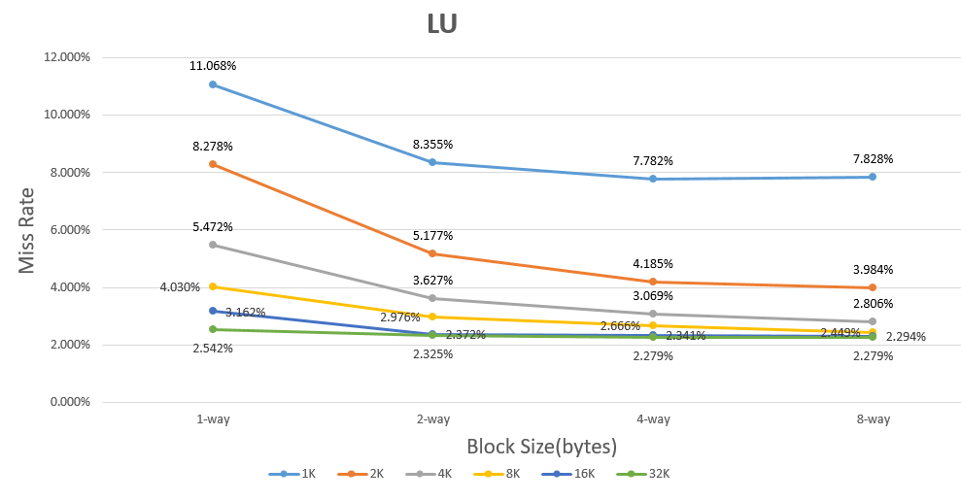

Analysis:

1. Radix:

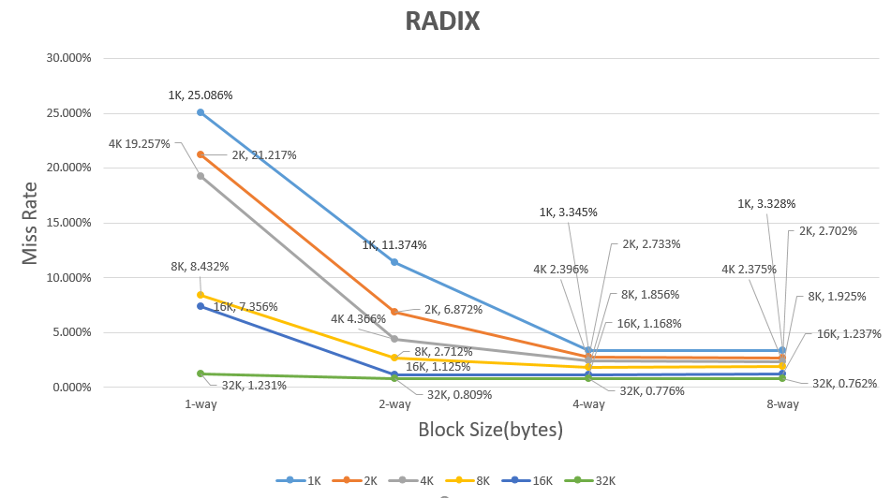

Analysis:

1. Total bit:

|  |  |  |  |  |
| --- | --- | --- | --- | --- |
| Associativit  Cache Size | 1-way | 2-way | 4-way | 8-way |
| 1K | 8560 | 8576 | 8592 | 8608 |
| 2K | 17088 | 17120 | 17152 | 17184 |
| 4K | 34112 | 34176 | 34240 | 34304 |
| 8K | 68096 | 68224 | 68352 | 68480 |
| 16K | 135936 | 136192 | 136448 | 136704 |
| 32K | 271360 | 271872 | 272384 | 272896 |

(單位：bit)